MORNINGTON YACHT CLUB FOUNDATION.-REPORT 30 November 2020.
The Trustees of the Foundation are pleased to provide members with an update on the activities of the Foundation for the period from 1 July to 30 November 2020. During this period we have received donations of $14,521.13 bringing the total funds received since the commencement of the Foundation to $123,684. We and the Board of the Club are very appreciative of the support that we have received which has enabled the Club to improve facilities and provide training craft which would not have been possible without your generous support. Unfortunately the subscription income of the Club has not been sufficient to provide the funding needed and therefore the provision of a tax effective funding method through the Australian Sports Foundation has been attractive.
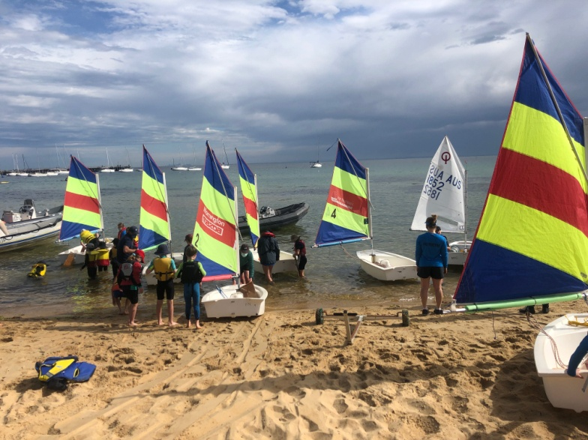
During this period the Foundation purchased six Opti dinghies for use in the recently launched Try Sailing Programme which has attracted significant interest from families wishing their children to see if they would be interested in sailing as an activity. These boats were christened at a ceremony on Thursday 3 December and are now in use.

The Club's rescue boat fleet is in need of attention with an ageing fleet of boats and engines. The Board at its November meeting agreed to purchase a new 6 metre Commorant 600 rib with a 80 hp outboard to be delivered at the end of January. The Foundation Board has agreed to contribute to this purchase the funds donated to our Rescue Boat appeal totaling $10,500 with the Club meeting the balance of the cost. Anyone who has not donated to this Appeal and would like to do so could do so through the Mornington Yacht Club Foundation at the Australian Sports Foundation website or through the office if that is easier for you. Your continued support would be greatly appreciated.

Looking to the future the Foundation is in the early stages of planning for a Business Lunch to be held at the Club in March as another means of generating funds. Members will recall that we had planned a lunch in April of this year which had attracted considerable member interest but unfortunately had to be cancelled due to the outbreak of COVID 19 . We trust that those who had booked for this event will be able to attend the new function. Further details will be advertised as soon as the arrangements can be finalised.

If members have any questions on the operation of the Foundation or any questions please send me an email on stuart.f.gooley@bigpond.com.

On behalf of the Trustees I would like to wish everyone a Safe and Happy Christmas and good sailing for the rest of the season.
Stuart Gooley
Chairman.

