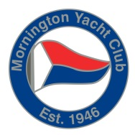
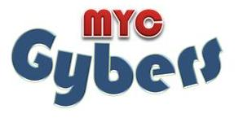
Mornington Yacht Club Gybers Program

Information and Registration Form

About the Program
Mornington Yacht Club (MYC) Gybers program’s vision is to provide a healthy and vibrant youth program at Mornington, which is a program of choice for youth members of MYC and interested youth on the Mornington Peninsula from the ages of 14 to 21.
Participants don’t have to own their own to participate.

The Gybers program is broken into 8 week blocks, you can participate in 1, 2 or 3 of the blocks scheduled for the season. The blocks enable you to schedule ‘fun time’ amongst your sailing time at MYC.

Is there a cost involved?

Participants of the program are required to be Youth members of MYC. By becoming a youth member it enables the Gyber to enjoy everything Mornington has to offer.
Any social or coaching activity may involve additional cost, depending on activity.
There is no cost associated with the program if you are a current MYC Youth member with a boat.

Gybers structure
Register for Gybers Block
Current MYC Member
Non member of MYC*
No Fee
Currently sailing, own boat & pay storage fees
Not currently sailing
Own boat &
pay storage
Do not own boat
Hire MYC boat for Block.

$250/block

* MYC Youth Membership rates – 1 year:

≤ 19y.o. - $106 20 y.o. - $146 21 y.o. - $186

Note: As a non-member you are able to participate in an organised sailing race 3 times before you require membership

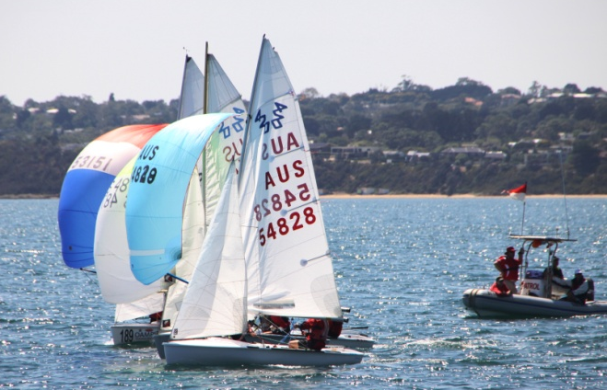
What you need to know about a Gybers block
On registering for a Gybers block you are committing to participating within the scheduled program for that block. One block is made up of 8 weeks programming that incorporates sailing and socialising.
If you don’t own your own boat you are able to hire a MYC boat for the duration of the block (See in detail above).

2014-2015 Gyber Blocks

BLOCK 1
November
1. Sat 1st – Mon 3rd full weekend Albury Wodonga Yacht Club Traveller
Sail Country Regatta
2. Friday 7th 7pm Activity & Venue tbc Social
3. Sunday 9th 10.00am Race Day/Club Championship Sailing
4. Sunday 16th 10.00am Race Day/Trophy Race Sailing
5. Sunday 23rd 10.00am Race Day/Club Championships & Coaching Sailing
6. Sunday 30th 10.00am Fun Race/Destination Sail Destination
December
7. Friday 5th 7.00pm Activity & Venue to be confirmed Social
8. Sunday 7th 10.00am Race Day/Club Championships Sailing

BLOCK 2
December
1. Sunday 21st 10.00am Race Day / Aggregate Series & Coaching Sailing
2. Sunday 28th afternoon Fun races / paddle boards etc Social
January 2015
3. Friday 16th 7.00pm Activity & Venue to be confirmed Social
4. Sunday 18th 10.00am Race Day/Trophy Race Sailing
5. Sunday 25th 10.00am Race Day/Aggregate Series Sailing
February
6. Sunday 1st 10.00am Race Day/Club Championships Sailing
7. Sunday 8th 10.00am Fun Race/Destination Destination
8. Sunday 15th 10.00am Coaching Clinic Sailing

BLOCK 3
February
1. Sunday 22nd 10.00am Race Day/Club Championships Sailing
2. Sat 28th – Sun 1st All day Schnapper Point Regatta, MYC Sailing Regatta
March
3. Sunday 15th 10.00am Race Day/Trophy Race Sailing
4. Friday 20th 7.00pm Activity & Venue to be confirmed Social
5. Sunday 22nd 10.00am Race Day/Club Championship & Coaching Sailing
6. Sunday 29th 10.00am Adventure Day Social/Sailing
April
7. Sunday 19th Race Day/Club Championships Sailing
8. Sunday 26th Fun Race Destination

All Gybers Friday 1st May 7.00pm End of Season Party Social!
Presentation

Please take your time reading through the registration and take note of the various dates detailed within the 3 blocks. If you have any questions regarding this registration or the program please contact Michelle Pickford on 0449 508 963 during business hours or michelle@morningtonyc.net.au .

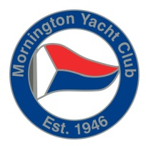
Registration Form - GYBERS
- Please enrol me in the following Gybers block/s:

- Block 1 | - Block 2 | - Block 3
- Hire of boat required for the following: ($250/block) |  |  |  |  | Block & &
- Block 1 | - Block 2 | - Block 3
- Membership forms attached.

GYBER INFORMATION
First Name: Surname:
Date of Birth: Male Female
Street Address:
Suburb: Pcode:

PRIMARY PARENT / GUARDIAN CONTACT DETAILS (for participants under 18 years of age)
Name: Relationship:
Telephone : Mobile:
Email :

SOME INFORMATION ABOUT YOU.
Are you a current Member at MYC? Yes / No If No, please complete membership forms & return
with Gybers Block registration
Are you actively sailing at MYC? Yes / No If Yes, please let us know
(ie Sunday morning fleet / Saturday sailing )

Do you have other sailing commitments outside of MYC?

If you are not currently sailing, can you let us know why not:

Would you like to sail as a crew? Yes / No
Are you organising to sail with a friend? Yes / No If Yes, who?
Please turn over

JUST A COUPLE MORE THINGS...
What type of social activities would you like to see within the program. These can be away from the yacht club.

Are there any dates within the block that you are concerned about?

Any other comments?

We look forward to your involvement at MYC this season
Please forward registrations by one of the following:
In person: Mail Fax: Email:
Mornington Yacht Club Michelle Pickford 03 5975 8355 michelle@morningtonyc.net.au
3 Schnapper Point Drive Po Box 291
Mornington Mornington 3931

Confirmation of your Gybers Registration will be forwarded to you.

