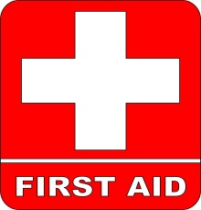
First Aid Locations

- MYC Club Room Cupboard (beside end bar)
  - AED – (Defibrillator)
  - First Aid Kit
  - Ambubag & Airways
  - Dry Clothing. (emergency only)
- Lower Floor- outside Disabled toilet
  - First aid cabinet
  - Spinal board
  - Neck Brace
- Mornington Marine Shed - yard
  - First aid kit
- Female Change-rooms
  - Trolley bed
- MYC Kitchen
  - 2 x reusable Ice packs in fridge
- Sailability (Days of operation only)
  - First Aid kit in BBQ area
- Race Office – Rescue boat kits
(all kits to be signed in & out and returned each day)
  - Specific kits for Sara & Hysport.
  - Retriever kept on-board at all times
  - 5 x mini kits

Please advise the office of any incidents, and/or use of first aid stock so it can be replenished asap.

